**Problem 1:**

**SOURCE CODE:**

#my_reduce function

x = 1

for i in range(1,10):

x= x * i

print(x)

Using reduce function:

from functools import reduce

reduce (lambda i,x: i*x, range(1,10))

**OUTPUT:**

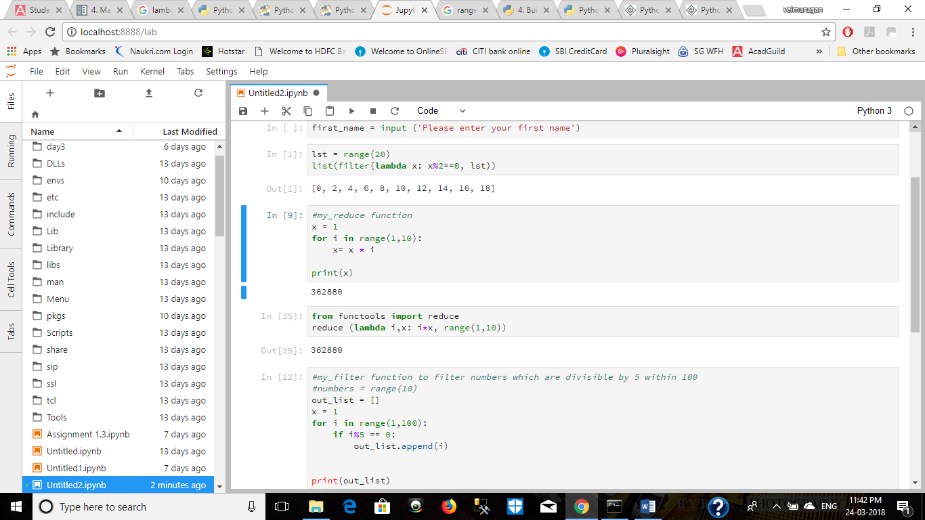

**Problem 2:**

**SOURCE CODE:**

#my_filter function to filter numbers which are divisible by 5 within 100

#numbers = range(10)

out_list = []

x = 1

for i in range(1,100):

if i%5 == 0:

out_list.append(i)

print(out_list)

Using Lambda function:

numbers = (range(1,100)

list(filter (lambda i:i%5==0, numbers))

**OUTPUT:**

